Dimensional Formula
# Source: AI Source: Provided by: [Data Path: Persons Table -> ID Column: 1, Name_En Column: Motasem Essam] -> From: [ChatGPT] on [7/17/2026]
A Dimensional Formula is a mathematical expression that represents a physical quantity in terms of the fundamental dimensions raised to appropriate powers. It shows how a derived quantity depends on the fundamental dimensions, regardless of the measurement units used.
Dimensional formulas are the foundation of Dimensional Analysis and are widely used in physics, engineering, chemistry, and applied mathematics to verify equations, derive relationships, and check the consistency of physical laws.

Definition
# Source: AI Source: Provided by: [Data Path: Persons Table -> ID Column: 1, Name_En Column: Motasem Essam] -> From: [ChatGPT] on [7/17/2026]
A Dimensional Formula is an expression that represents a physical quantity as a combination of the fundamental dimensions raised to suitable powers.

Purpose
# Source: AI Source: Provided by: [Data Path: Persons Table -> ID Column: 1, Name_En Column: Motasem Essam] -> From: [ChatGPT] on [7/17/2026]
Dimensional formulas are used to:
- Express derived quantities using fundamental dimensions.
- Verify the dimensional correctness of equations.
- Derive relationships between physical quantities.
- Detect errors in formulas.
- Support dimensional analysis.

Characteristics
# Source: AI Source: Provided by: [Data Path: Persons Table -> ID Column: 1, Name_En Column: Motasem Essam] -> From: [ChatGPT] on [7/17/2026]
Dimensional formulas:
- Use dimension symbols, not units.
- Are independent of the system of measurement.
- Represent only the physical nature of a quantity.
- Ignore numerical constants (such as 2, π, or ½).
- Use exponents to indicate how dimensions combine.

Fundamental Dimensions
# Source: AI Source: Provided by: [Data Path: Persons Table -> ID Column: 1, Name_En Column: Motasem Essam] -> From: [ChatGPT] on [7/17/2026]
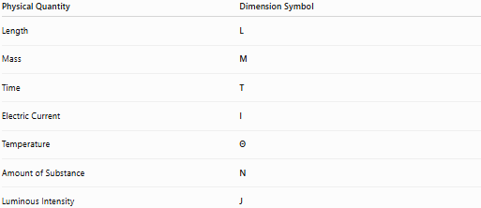
Physical Quantity | Dimension Symbol
Length | L
Mass | M
Time | T
Electric Current | I
Temperature | Θ
Amount of Substance | N
Luminous Intensity | J

General Form
# Source: AI Source: Provided by: [Data Path: Persons Table -> ID Column: 1, Name_En Column: Motasem Essam] -> From: [ChatGPT] on [7/17/2026]
A dimensional formula is written as:
$$\boxed{\left[M^{a}L^{b}T^{c}I^{d}Θ^{e}N^{f}J^{g}\right]}$$
where:
- $a,b,c,d,e,f,g$are real-number exponents.
- Positive exponents indicate multiplication.
- Negative exponents indicate division.
- Zero exponents are omitted.

Examples of Dimensional Formulas
# Source: AI Source: Provided by: [Data Path: Persons Table -> ID Column: 1, Name_En Column: Motasem Essam] -> From: [ChatGPT] on [7/17/2026]
Length
Dimension:
$$\boxed{\left[L\right]}$$

Mass
Dimension:
$$\boxed{\left[M\right]}$$

Time
Dimension:
$$\boxed{\left[T\right]}$$

Area
Area = Length × Length
$$\boxed{\left[L^{2}\right]}$$

Volume
Volume = Length × Length × Length
$$\boxed{\left[L^{3}\right]}$$

Speed (Velocity)
Speed = Distance / Time
$$\boxed{\left[LT^{-1}\right]}$$

Acceleration
Acceleration = Speed / Time
$$\boxed{\left[LT^{-2}\right]}$$

Force
Force = Mass × Acceleration
$$[M][LT^{-2}]=\boxed{\left[MLT^{-2}\right]}$$

Pressure
Pressure = Force / Area
$$\frac{MLT^{-2}}{L^{2}}=\boxed{\left[ML^{-1}T^{-2}\right]}$$

Density
Density = Mass / Volume
$$\frac{M}{L^{3}}=\boxed{\left[ML^{-3}\right]}$$

Momentum
Momentum = Mass × Velocity
$$M×LT^{-1}=\boxed{\left[MLT^{-1}\right]}$$

Energy (Work)
Energy = Force × Distance
$$MLT^{-2}×L=\boxed{\left[ML^{2}T^{-2}\right]}$$

Power
Power = Energy / Time
$$\frac{ML^{2}T^{-2}}{T}=\boxed{\left[ML^{2}T^{-3}\right]}$$

Frequency
Frequency = 1 / Time
$$\boxed{\left[T^{-1}\right]}$$

Table of Common Dimensional Formulas
# Source: AI Source: Provided by: [Data Path: Persons Table -> ID Column: 1, Name_En Column: Motasem Essam] -> From: [ChatGPT] on [7/17/2026]
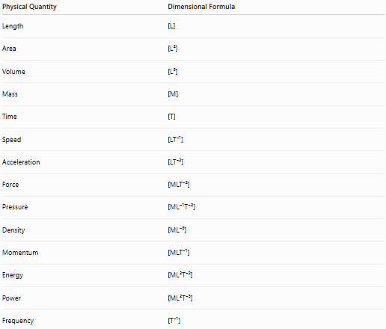
Physical Quantity | Dimensional Formula
Length | [L]
Area | [L²]
Volume | [L³]
Mass | [M]
Time | [T]
Speed | [LT⁻¹]
Acceleration | [LT⁻²]
Force | [MLT⁻²]
Pressure | [ML⁻¹T⁻²]
Density | [ML⁻³]
Momentum | [MLT⁻¹]
Energy | [ML²T⁻²]
Power | [ML²T⁻³]
Frequency | [T⁻¹]

Applications
# Source: AI Source: Provided by: [Data Path: Persons Table -> ID Column: 1, Name_En Column: Motasem Essam] -> From: [ChatGPT] on [7/17/2026]
Dimensional formulas are used in:
- Physics
- Mechanical engineering
- Civil engineering
- Aerospace engineering
- Fluid mechanics
- Thermodynamics
- Electromagnetism
- Scientific research
- Mathematical modeling

Importance
# Source: AI Source: Provided by: [Data Path: Persons Table -> ID Column: 1, Name_En Column: Motasem Essam] -> From: [ChatGPT] on [7/17/2026]
Dimensional formulas help to:
- Verify equations.
- Detect mathematical mistakes.
- Derive unknown relationships.
- Check consistency of physical laws.
- Understand how quantities depend on one another.

Limitations
# Source: AI Source: Provided by: [Data Path: Persons Table -> ID Column: 1, Name_En Column: Motasem Essam] -> From: [ChatGPT] on [7/17/2026]
Dimensional formulas cannot:
- Determine numerical constants (π, 2, ½, etc.).
- Distinguish different quantities having identical dimensions.
Example:
Both work and torque have the dimensional formula:
$$\left[ML^{2}T^{-2}\right]$$
but they represent different physical concepts.

Common Mistakes
# Source: AI Source: Provided by: [Data Path: Persons Table -> ID Column: 1, Name_En Column: Motasem Essam] -> From: [ChatGPT] on [7/17/2026]
- Confusing dimensions with units.
- Forgetting negative exponents.
- Omitting required dimensions.
- Assuming identical dimensional formulas always indicate identical physical quantities.
- Ignoring the Principle of Dimensional Homogeneity.

Dimensional Formula vs. Dimension
# Source: AI Source: Provided by: [Data Path: Persons Table -> ID Column: 1, Name_En Column: Motasem Essam] -> From: [ChatGPT] on [7/17/2026]
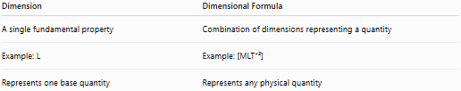
Dimension | Dimensional Formula
A single fundamental property | Combination of dimensions representing a quantity
Example: L | Example: [MLT⁻²]
Represents one base quantity | Represents any physical quantity

Dimensional Formula vs. Unit
# Source: AI Source: Provided by: [Data Path: Persons Table -> ID Column: 1, Name_En Column: Motasem Essam] -> From: [ChatGPT] on [7/17/2026]
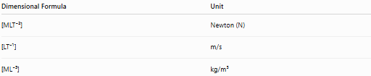
Dimensional Formula | Unit
[MLT⁻²] | Newton (N)
[LT⁻¹] | m/s
[ML⁻³] | kg/m³
The dimensional formula describes the physical nature, while the unit measures its magnitude.

Key Points
# Source: AI Source: Provided by: [Data Path: Persons Table -> ID Column: 1, Name_En Column: Motasem Essam] -> From: [ChatGPT] on [7/17/2026]
- A Dimensional Formula expresses a physical quantity using the fundamental dimensions.
- It is independent of measurement units.
- It is written using symbols such as M, L, T, I, Θ, N, and J.
- It is used to verify equations and derive physical relationships.
- It forms the basis of Dimensional Analysis.

Conclusion
# Source: AI Source: Provided by: [Data Path: Persons Table -> ID Column: 1, Name_En Column: Motasem Essam] -> From: [ChatGPT] on [7/17/2026]
A Dimensional Formula is a symbolic expression that represents a physical quantity in terms of the fundamental dimensions raised to appropriate powers. It describes the physical nature of both fundamental and derived quantities independently of the units used to measure them. Dimensional formulas are indispensable in physics, engineering, chemistry, and applied mathematics, where they are used to verify equations, derive relationships, ensure dimensional consistency, and detect errors in scientific calculations.

